**ANALYSIS OF CUSTOMER BASE, MEAL PREFERENCE, AND OPERATIONAL STRATEGIES FOR AN INDIAN FOOD COMPANY**

**Executive Summary:**

This report presents the findings and recommendations based on an analysis of order information from a food company operating in 51 cities across eight regions in India. The aim of the analysis was to gain insights into the customer base, meal preferences, fluctuations in demand, and opportunities for operational improvements and food waste reduction. [Click here](https://github.com/Sewanu708/Analysis-of-Customer-Base-Meal-Preferences-and-Operational-Strategies-for-an-Indian-Food-Company/blob/main/Datacamp%20Project.ipynb) to see the python analysis.

The key insights and recommendations are summarized as follows:

1. **POPULAR FOOD IN EACH REGIONS**

* Region 56: The most popular food category in this region is **BEVERAGES,** accounting for over **32%** of the total orders in the region. **Rice Bowl** and **Sandwich** both taking second and third respectively, contributed approximately **16%** and **14%** respectively to the total orders.
* Region 34: The most popular food category in this region is **BEVERAGES,** accounting for over **29%** of the total orders in the region. **Rice Bowl** and **Sandwich** both taking second and third respectively, contributed approximately **23%** and **14%** respectively to the total orders.
* Region 71: The most popular food category in this region is **BEVERAGES**, accounting for over **91%** of the total orders in the region. **Sandwich** and **Other Snacks** both taking second and third respectively, contributed approximately **2%** and **2%** respectively to the total orders.
* Region 85: The most popular food category in this region is **RICE BOWL,** accounting for over **31%** of the total orders in the region. **Beverages** and **Sandwich** both taking second and third respectively, contributed approximately **24%** and **15%** respectively to the total orders.
* Region 77: The most popular food category in this region is **BEVERAGES,** accounting for over **40%** of the total orders in the region. **Sandwich** and **Rice Bowl** both taking second and third respectively, contributed approximately **18%** and **15%** respectively to the total orders.
* Region 23: The most popular food category in this region is **BEVERAGES,** accounting for over **52%** of the total orders in the region. **Sandwich** and **Extras** both taking second and third respectively, contributed approximately **14%** and **10%** respectively to the total orders.
* Region 93: The most popular food category in this region is **BEVERAGES** accounting for over **52%** of the total orders in the region. **Rice Bowl** and **Pizza** both taking second and third respectively, contributed approximately **15%** and **8%** respectively to the total orders.
* Region 35: The most popular food category in this region is **RICE BOWL** accounting for over **46%** of the total orders in the region. **Beverages** and **Sandwich** both taking second and third respectively, contributed approximately **26%** and **12%** respectively to the total orders.

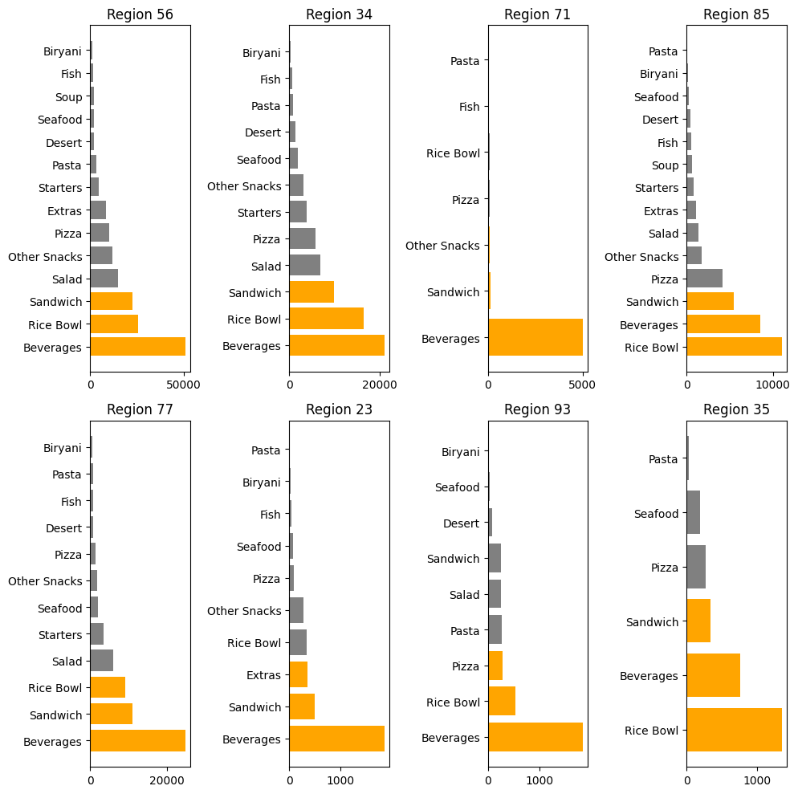

1. **EVALUATION OF FULFILLMENT CENTERS IN CITIES HAVING MORE THAN ONE FULFILLMENT CENTERS:**

There are two cities with more than two Fulfillment centers. These city names are however not known as they are represented with code. These city codes are 526 and 590.

City with code 526 has 8 Fulfillment centers while city with code 590 has 9 Fulfillment centers.

* Regarding the Fulfillment centers in City 526: These centers performed poorly in terms of orders compared to the average orders in their respective region. Below is a graphical representation that illustrates the difference between the average orders in each Fulfillment center and the average orders in the region.

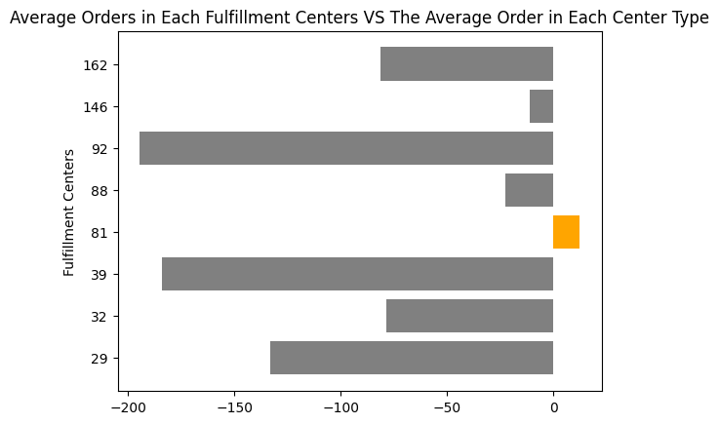

The graphs clearly show that most Fulfillment centers performed well below average. Merging these centers can be a solution since a significant amount of money is being used to fund them.

* Performance of the Fulfillment centers in city 590: The performance of most Fulfillment centers here is quite encouraging as most of them performed far above average. Their performance here was also evaluated based on their average orders compared to the average orders in its region.

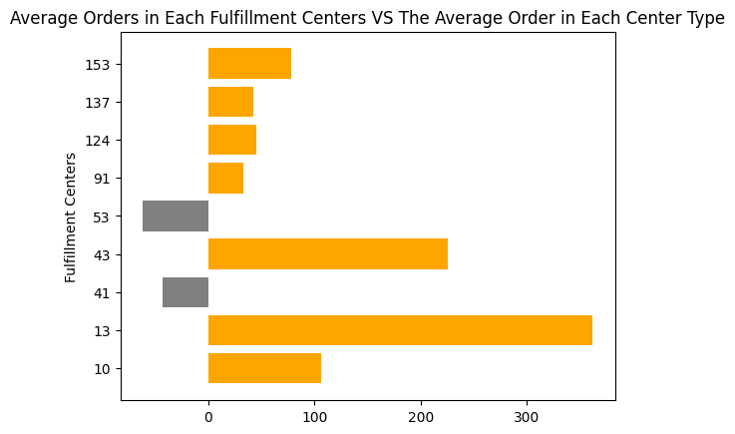 Below is graphical representation showing the difference between the average orders in each fulfillment centers and the average orders in the region.

From the visuals below, it’s very evident that city 590 is performing far better than city 526.

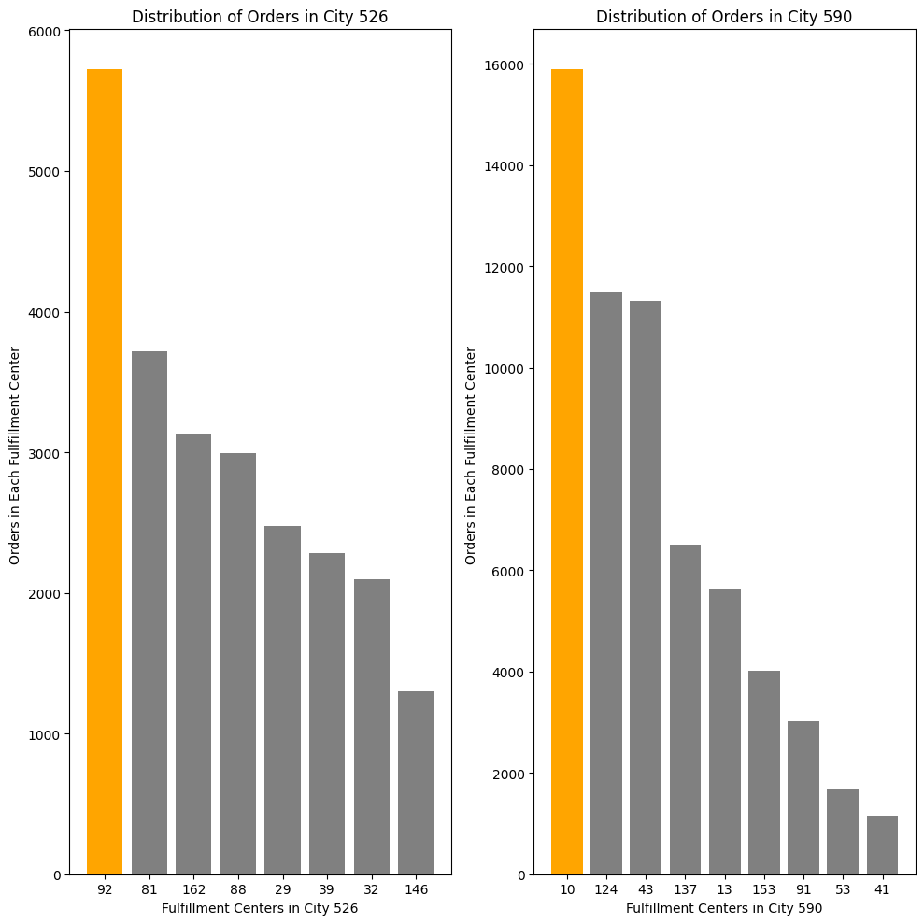

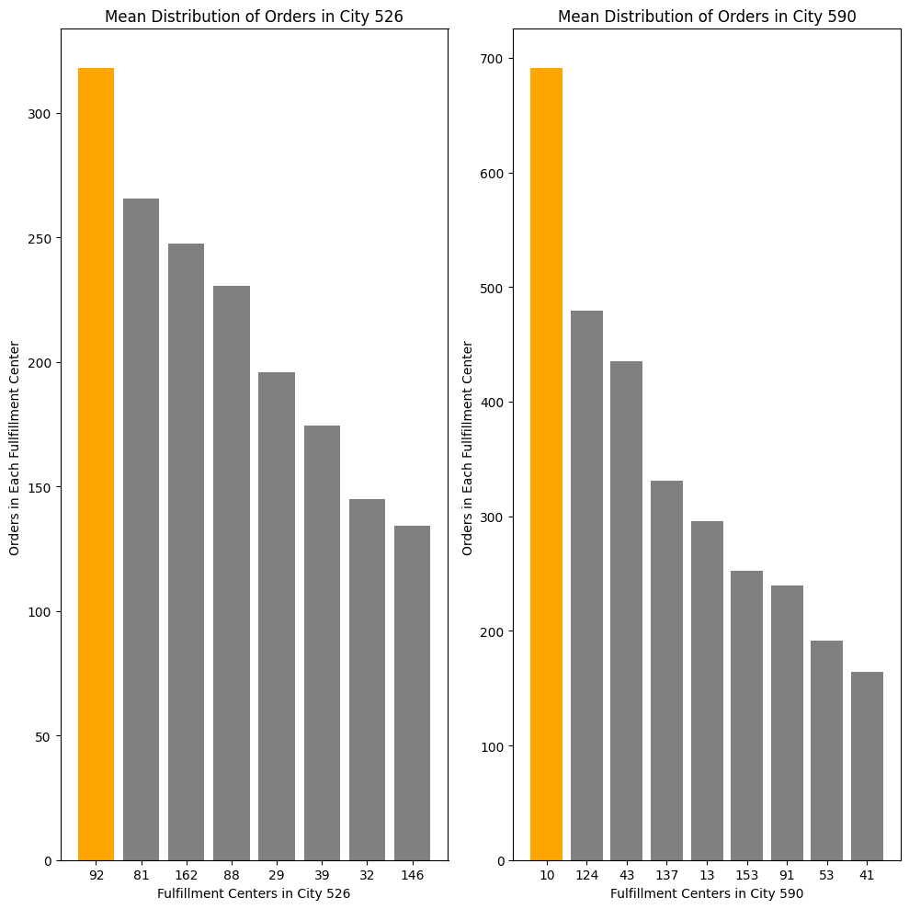

1. **Effectiveness of Email Campaign and Website Promotions**: From the diagram below, it's obvious that the total number of emailed featured orders is 98. This is equivalent to 7.4% of the total orders placed. These 98 emailed featured orders performed quite far from average. Out of the 1333 orders placed, 1235 were non-emailed featured orders. In order to avoid biased analysis, I randomly sampled 98 orders from these non-emailed featured orders.

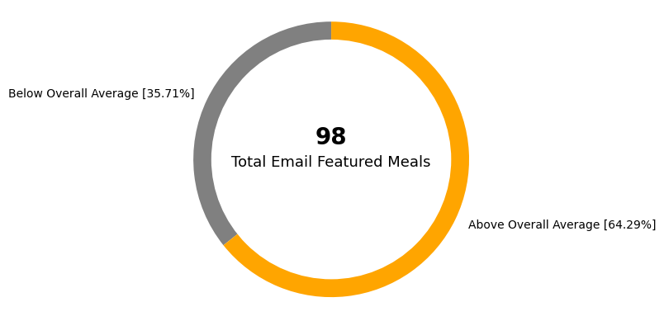

**COMPARING THESE 98 NON-EMAILED FEATURED ORDERS WITH THE 98 EMAILED FEATURED ORDERS**

|  |  |  |  |
| --- | --- | --- | --- |
| Metrics | Emailed Featured Orders | Non emailed Featured Orders | Explanation |
|  |  |  |  |
| Mean | 619 | 211 | Mean value represents the average number of orders for emailed featured orders and non-emailed featured orders. |
| Median | 351.5 | 121.0 | Median value represents the middle value of the ordered data for emailed featured orders and non-emailed featured orders. It is also equivalent to the 50th percentile. |
| 25th Percentile | 149 | 53 | The 25th percentile represents the value below which 25% of the data falls for emailed featured orders and non-emailed featured orders. |
| 75th Percentile | 642 | 290 | The 75th percentile represents the value below which 75% of the data falls for emailed featured orders and non-emailed featured orders. |
| 100th Percentile | 7399 | 2105 | The 100th percentile represents the maximum value in the dataset for emailed featured orders and non-emailed featured orders. |

From the analysis, it’s very clear that emailed featured orders performed very well more than non-emailed featured orders.

**WEBSITE FEATURED ORDERS**

|  |  |  |  |
| --- | --- | --- | --- |
| Metrics | Website Featured Orders | Not Featured on Website | Description |
| Mean | 553 | 202 | Mean value represents the average number of orders for website featured orders and orders not featured on the website. |
| Median | 323 | 135 | Median value represents the middle value of the ordered data for website featured orders and orders not featured on the website. It is also equivalent to the 50th percentile. |
| 25th Percentile | 149 | 53 | The 25th percentile represents the value below which 25% of the data falls for website featured orders and orders not featured on the website. |
| 75th Percentile | 655 | 285 | The 75th percentile represents the value below which 75% of the data falls for website featured orders and orders not featured on the website. |
| 100th Percentile | 7399 | 1095 | The 100th percentile represents the maximum value in the dataset for website featured orders and orders not featured on the website. |

Orders promoted both via website and email performed far very well than order featured on either website or email. Although the data is skewed, this type of orders however have a mean of 882 and a median of 473, meaning that 50% of the data s below 473.

1. RECOMMENDATIONS:
2. Promoting meals via email and the website has proven to be effective. Therefore, meals should be promoted through either mail or the website. Promoting through both channels can also be advised. However, if the cost of promoting meals through both channels isn't feasible, promoting through one channel is acceptable.
3. In City 526, the Fulfillment centers performed below average. However, merging some of these Fulfillment centers is a welcomed idea. The surest way to proceed would be to merge all eight Fulfillment centers into two categories. Fulfillment Centers 81, 88, and 146 should be merged into one group, while Fulfillment Centers 162, 92, 39, 32, and 29 should be merged into another group.
4. Most fulfillment centers in city 590 performed far above average. However, merging some that performed far below average is the surest way to proceed. Fulfillment center 53 and 41 should be merged while fulfillment center 137, 124 and 91 should be placed on check for the throughout the year.
5. Region 56 is the best performing region, averaging 303 orders per week.
6. Meals with fewer than 50 orders in the last three years should not be prepared due to their low performance. Some of these meals include:

* Biryani in Region 93 had only 15 orders in the last three years. It is suggested that the production of this meal in this region should be discontinued.
* Fish in region 23 had only 42 orders in the last three years. It is suggested that this meal should be scrapped or made on order.
* Pasta in region 23 had only 13 orders. It is suggested that it should be scrapped in the region.
* It is suggested that Pasta should not be made in region 35, as it recorded 28 orders in the last three years.
* Seafood in region 93 had only 42 orders. It is suggested that it should be scrapped in the region or made on order.
* Pasta in Region 71 had only 14 orders. It is suggested that it should be discontinued.

[Click here](https://github.com/Sewanu708/Analysis-of-Customer-Base-Meal-Preferences-and-Operational-Strategies-for-an-Indian-Food-Company/blob/main/Datacamp%20Project.ipynb) to see the python analysis.